**Data Warehousing and Data Mining.**

**Name : Antuley Aman Siraj.**

**Roll No. : 23CO25.**

**Class : TE-CO**

**Batch : 01**

**Experiment - 03**

**Aim:** Perform various OLAP operations such as slice, dice, drilldown, rollup.

**Theory:**

OLAP stands for Online Analytical Processing Server. It is a software technology that allows users to analyze information from multiple database systems at the same time. It is based on a multidimensional data model and allows the user to query on multi-dimensional data (eg.student -> course - > sem). OLAP databases are divided into one or more cubes and these cubes are known as Hyper-cubes.

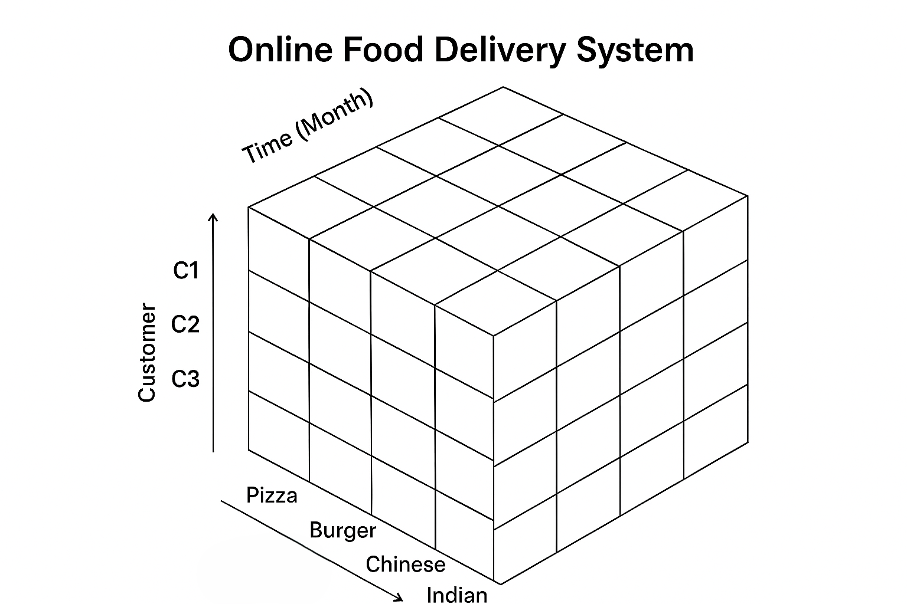

**OLAP operations:** There are five basic analytical operations that can be performed on an OLAP cube:

**1. Drill down:** In drill-down operation, the less detailed data is converted into highly detailed data. It can be done by: Moving down in the concept hierarchy Adding a new dimension In the cube given in overview section, the drill down operation is performed by moving down in the concept hierarchy course dimension (Products -> Items)

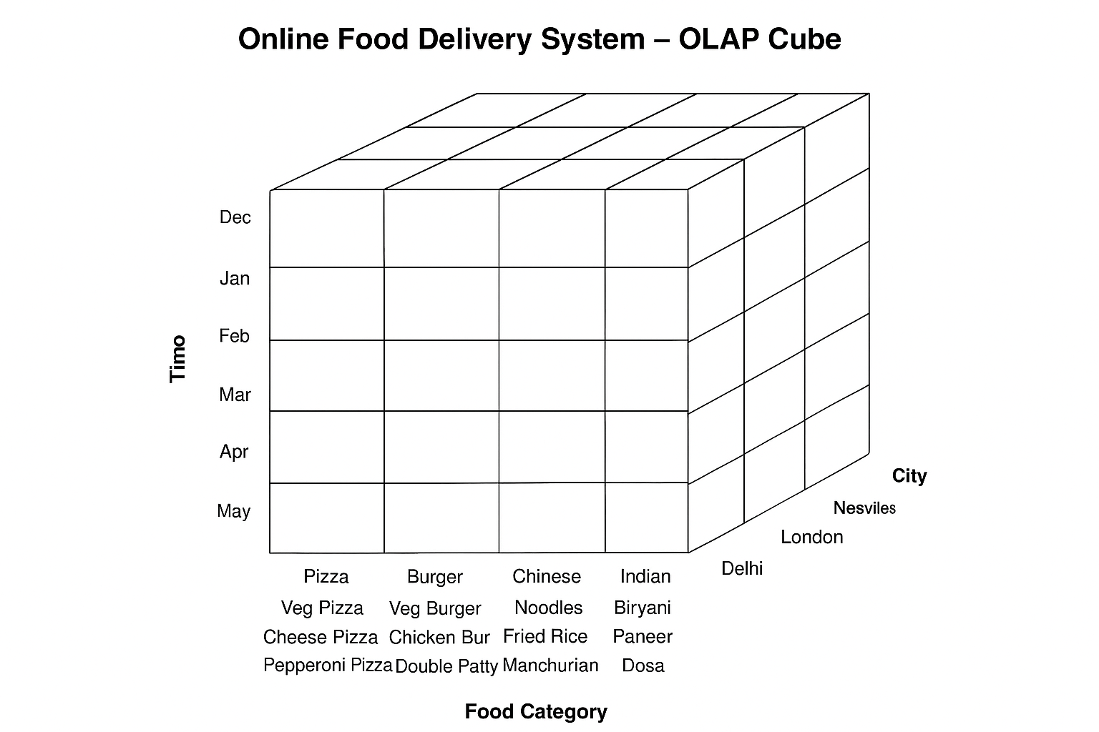

2. **Roll up:** It is just opposite of the drill-down operation. It performs aggregation on the OLAP cube. It can be done by:

Climbing up in the concept hierarchy Reducing the dimensions

In the cube given in the overview section, the roll-up operation is performed by climbing up in the concept hierarchy of Semester dimension (Sem -> Year).

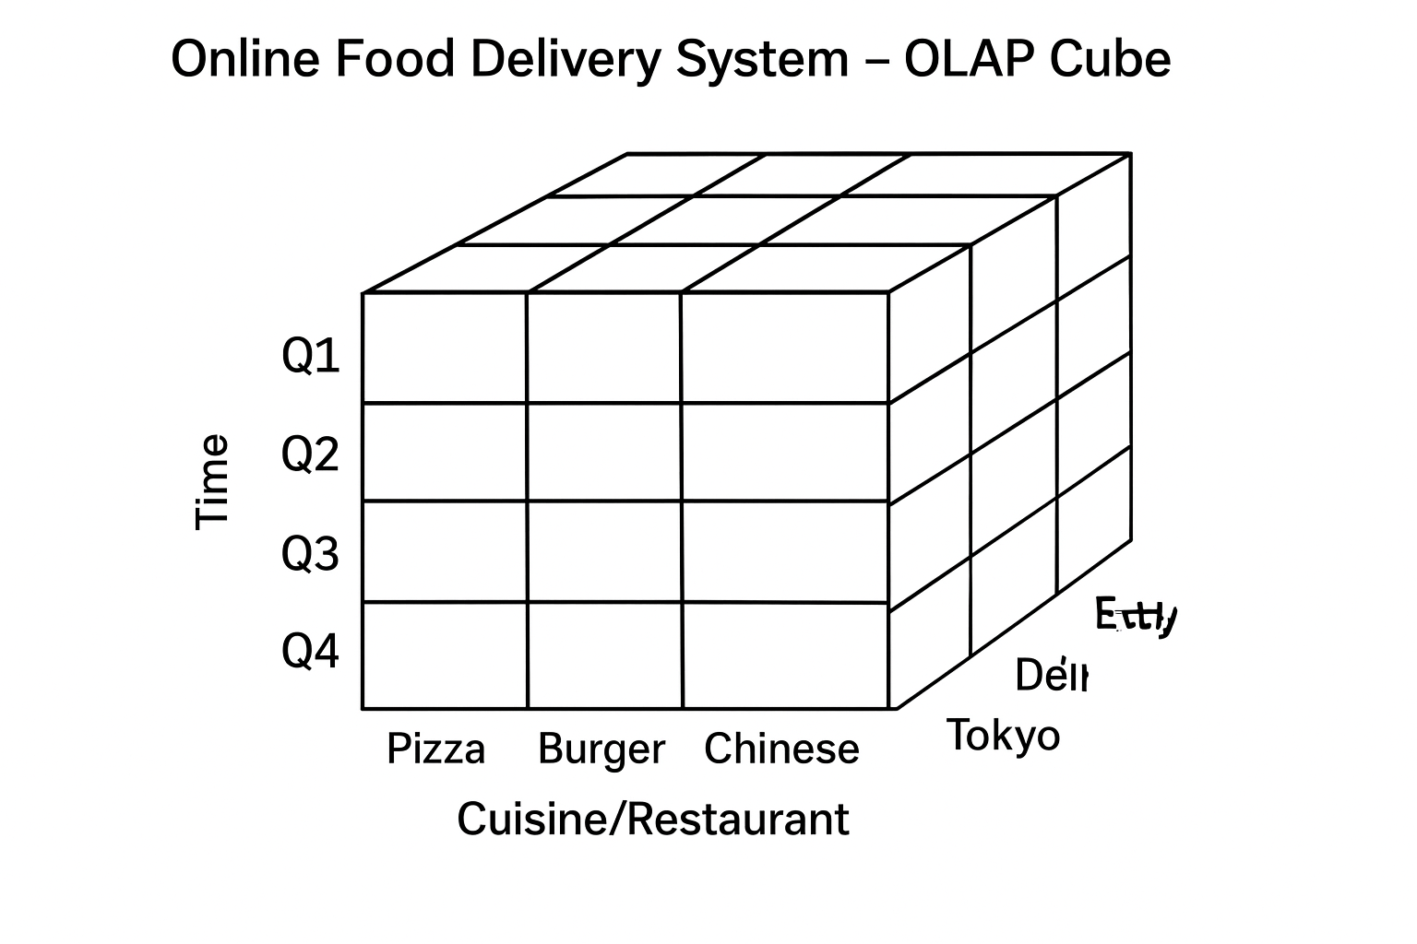

**3. Dice:** It selects a sub-cube from the OLAP cube by selecting two or more dimensions. In the cube given in the overview section, a subcube is selected by selecting following dimensions with criteria:

**Time (Months)** = *Jan, Feb, Mar* (Quarter 1)

**Location (Cities)** = *New York, Delhi*

**Food Items** = *Pizza, Burger*

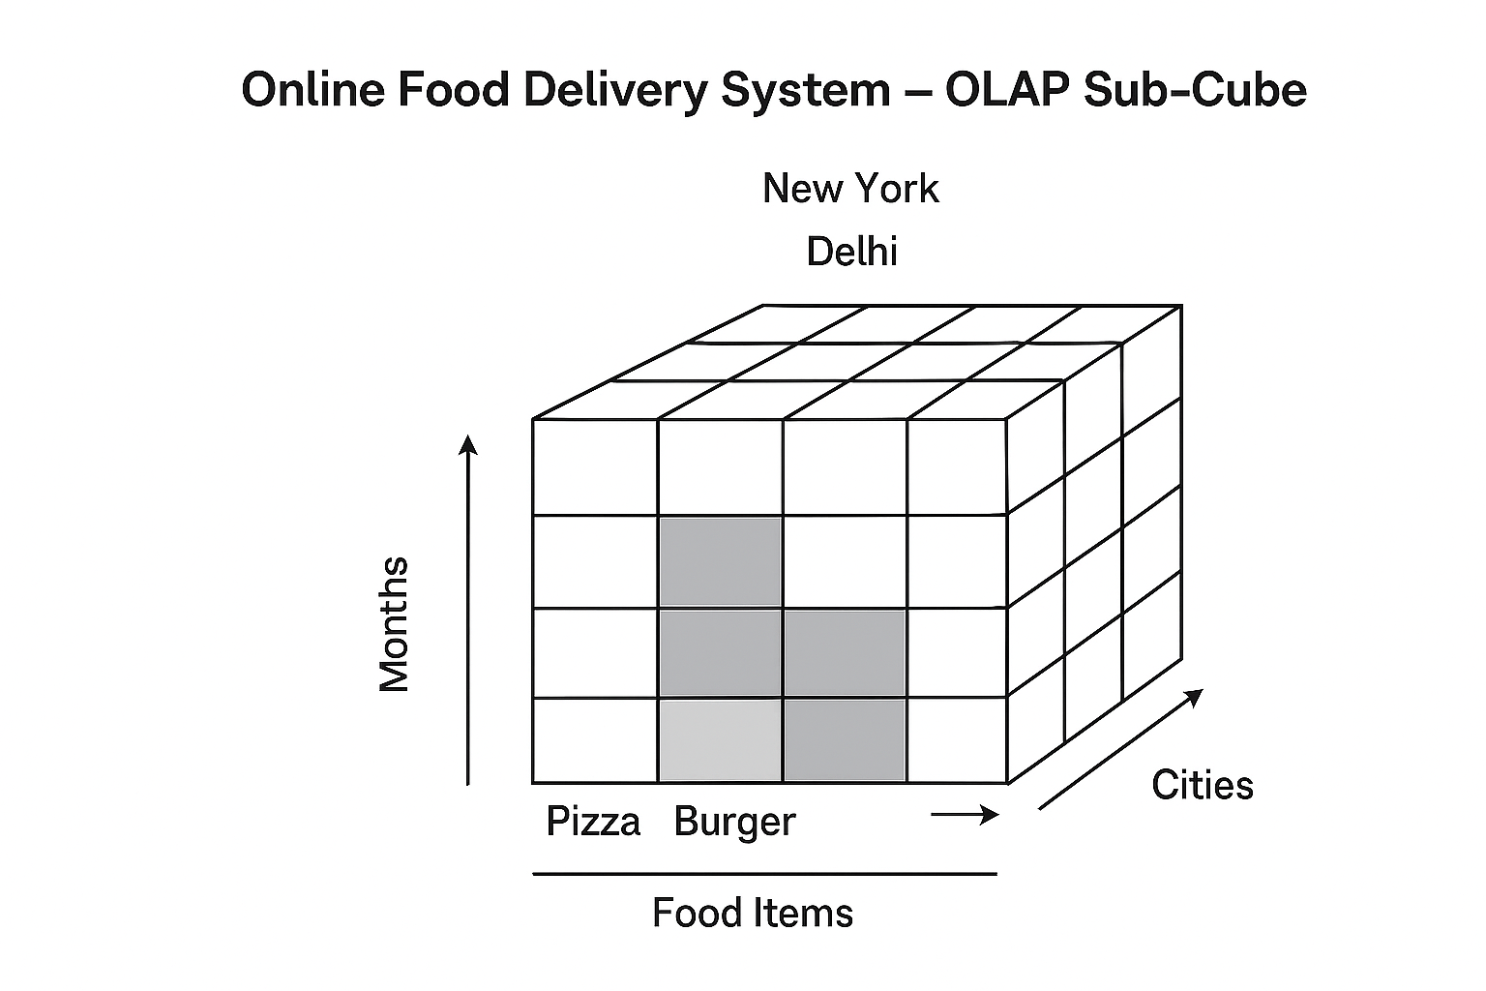

**4. Slice:** It selects a single dimension from the OLAP cube which results in a new sub-cube creation. In the cube given in the overview section,

Slice is performed on the dimension Student.

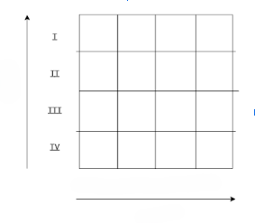

**5. Pivot:** It is also known as rotation operation as it rotates the current view to get a new view of the representation. In the sub-cube obtained after the slice operation, performing pivot operation gives a new view of it.

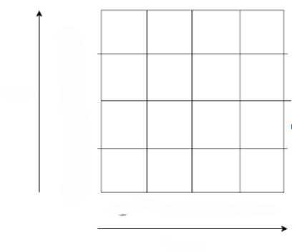

**Conclusion:** Hence we have studied the various OLAP Operations